Star Bipyramid
# Source: AI Source: Provided by: [Data Path: Persons Table -> ID Column: 1, Name_En Column: Motasem Essam] -> From: [ChatGPT] on [7/25/2026]

Definition
# Source: AI Source: Provided by: [Data Path: Persons Table -> ID Column: 1, Name_En Column: Motasem Essam] -> From: [ChatGPT] on [7/25/2026]
A Star Bipyramid is a three-dimensional geometric solid formed by extending the concept of a bipyramid using a star-shaped polygon as its central base.
Instead of a regular convex polygon, such as a triangle, square, or pentagon, the central base has a star-polygon arrangement. Two pyramidal portions extend from opposite sides of this central base, meeting at two apexes.
The resulting solid has a star-shaped cross-section around its middle and triangular or other pyramidal side surfaces, depending on its construction.

Simple Definition
# Source: AI Source: Provided by: [Data Path: Persons Table -> ID Column: 1, Name_En Column: Motasem Essam] -> From: [ChatGPT] on [7/25/2026]
A Star Bipyramid is a bipyramid whose central polygonal arrangement is star-shaped rather than convex.

Geometric Structure
# Source: AI Source: Provided by: [Data Path: Persons Table -> ID Column: 1, Name_En Column: Motasem Essam] -> From: [ChatGPT] on [7/25/2026]
A star bipyramid can be described using three main components:
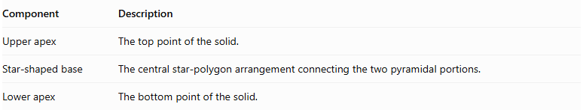
Component | Description
Upper apex | The top point of the solid.
Star-shaped base | The central star-polygon arrangement connecting the two pyramidal portions.
Lower apex | The bottom point of the solid.

Face Structure
# Source: AI Source: Provided by: [Data Path: Persons Table -> ID Column: 1, Name_En Column: Motasem Essam] -> From: [ChatGPT] on [7/25/2026]
The face structure depends on how the star-shaped base is constructed and connected to the apexes.
For a bipyramid constructed from a star polygon with $n$ boundary vertices, with each apex connected to every base vertex:
- The upper portion consists of $n$ triangular faces.
- The lower portion consists of $n$ triangular faces.
- The central star-shaped base is internal and is not an external face.
For this construction, the face count is:
$$F=2n$$

Edge Structure
# Source: AI Source: Provided by: [Data Path: Persons Table -> ID Column: 1, Name_En Column: Motasem Essam] -> From: [ChatGPT] on [7/25/2026]
The edges can be grouped into:
- Upper lateral edges: connect the upper apex to the star-polygon vertices.
- Lower lateral edges: connect the lower apex to the star-polygon vertices.
- Central boundary edges: form the star-polygon boundary.
For a construction with $n$ base vertices:
$$E=3n$$

Vertex Structure
# Source: AI Source: Provided by: [Data Path: Persons Table -> ID Column: 1, Name_En Column: Motasem Essam] -> From: [ChatGPT] on [7/25/2026]
The vertices consist of:
- One upper apex.
- One lower apex.
- $n$ vertices belonging to the central star-polygon boundary.
Therefore:
$$V=n+2$$

Mathematical Properties
# Source: AI Source: Provided by: [Data Path: Persons Table -> ID Column: 1, Name_En Column: Motasem Essam] -> From: [ChatGPT] on [7/25/2026]
For the described construction:
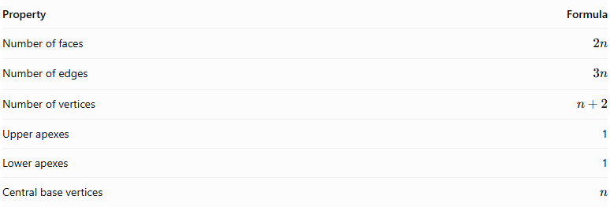
Property | Formula
Number of faces | $$2n$$
Number of edges | $$3n$$
Number of vertices | $$n+2$$
Upper apexes | 1
Lower apexes | 1
Central base vertices | $$n$$
Euler's formula for a closed polyhedral surface is:
$$V-E+F=2$$
Substituting:
$$(n+2)-3n+2n=2$$
The formula is satisfied for a valid polyhedral surface with the specified connectivity.
Important: A star-shaped base can be interpreted in different ways. A self-intersecting star polygon and a concave simple polygon do not necessarily produce the same geometry or topology. The formulas above assume a bipyramidal construction with $n$ distinct base vertices and $2n$ triangular side faces.

Surface Area and Volume
# Source: AI Source: Provided by: [Data Path: Persons Table -> ID Column: 1, Name_En Column: Motasem Essam] -> From: [ChatGPT] on [7/25/2026]
For a star bipyramid made from two pyramidal portions sharing a central base:
Surface Area
The external surface area is the sum of the areas of the upper and lower triangular faces:
$$SA={SA}_{upper}+{SA}_{lower}$$
The internal central base is excluded.
Volume
If the central base has area $B$, and the upper and lower apexes have perpendicular heights $h_{u}$ and $h_{l}$:
$$V=\frac{1}{3}B(h_{u}+h_{l})$$
This formula applies when the two pyramidal portions form a valid solid without overlapping or self-intersecting interiors.

Relationship to Other Solids
# Source: AI Source: Provided by: [Data Path: Persons Table -> ID Column: 1, Name_En Column: Motasem Essam] -> From: [ChatGPT] on [7/25/2026]
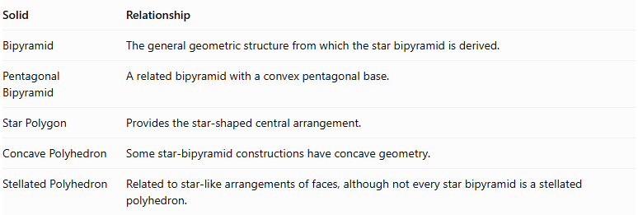
Solid | Relationship
Bipyramid | The general geometric structure from which the star bipyramid is derived.
Pentagonal Bipyramid | A related bipyramid with a convex pentagonal base.
Star Polygon | Provides the star-shaped central arrangement.
Concave Polyhedron | Some star-bipyramid constructions have concave geometry.
Stellated Polyhedron | Related to star-like arrangements of faces, although not every star bipyramid is a stellated polyhedron.

Constructing Star Bipyramid in Solid Geometry

Geometric Instruments Used
# Source: AI Source: Provided by: [Data Path: Persons Table -> ID Column: 1, Name_En Column: Motasem Essam] -> From: [ChatGPT] on [7/25/2026]
The construction uses traditional geometric instruments rather than coordinate-based construction.

Instrument | Purpose
Ruler | Drawing straight edges and connecting vertices
Compass | Drawing circles and transferring equal distances
Protractor | Measuring and constructing central angles
Set Square | Constructing perpendicular lines
Pencil | Marking vertices, apices, and edges
Eraser | Removing unnecessary construction lines
Drawing Paper | Providing the construction surface

Instrument-Based Construction Procedures

Constructing the Star-Polygon Base
# Source: AI Source: Provided by: [Data Path: Persons Table -> ID Column: 1, Name_En Column: Motasem Essam] -> From: [ChatGPT] on [7/25/2026]
- Draw a circle using a compass.
- Mark the center of the circle.
- Divide the circumference into $n$ equal angular sections using a protractor.
- Calculate the central angle:
$$θ=\frac{{360}^{∘}}{n}$$
- Mark the $n$ equally spaced points around the circumference.
- Select the required star-polygon step $k$.
- Starting from the first vertex, connect every $k$-th vertex using a ruler.
- Continue connecting the vertices according to the same step pattern until the star polygon is completed.
For example, a pentagram $\{5/2\}$ is constructed by connecting every second vertex of a regular pentagon's five equally spaced vertices.

Constructing the First Pyramid
# Source: AI Source: Provided by: [Data Path: Persons Table -> ID Column: 1, Name_En Column: Motasem Essam] -> From: [ChatGPT] on [7/25/2026]
- Identify the center of the star polygon.
- Construct a perpendicular line passing through the center of the base.
- Mark the first apex above the star-polygon plane.
- Connect the apex to every vertex of the star polygon.
- Form the triangular regions connecting the apex to consecutive vertices according to the star polygon's edge sequence.

Constructing the Second Pyramid
# Source: AI Source: Provided by: [Data Path: Persons Table -> ID Column: 1, Name_En Column: Motasem Essam] -> From: [ChatGPT] on [7/25/2026]
- Extend the perpendicular axis through the star-polygon plane in the opposite direction.
- Mark the second apex below the base plane.
- Connect the second apex to every vertex of the star polygon.
- Form the corresponding triangular regions on the opposite side.

Completing the Star Bipyramid
# Source: AI Source: Provided by: [Data Path: Persons Table -> ID Column: 1, Name_En Column: Motasem Essam] -> From: [ChatGPT] on [7/25/2026]
- Check that both pyramidal structures share the same star-polygon base.
- Ensure that the two apices are on opposite sides of the base plane.
- Darken the visible edges.
- Represent hidden edges using dashed lines when necessary.
- Distinguish intersecting star-polygon edges clearly.
- Remove unnecessary construction marks.
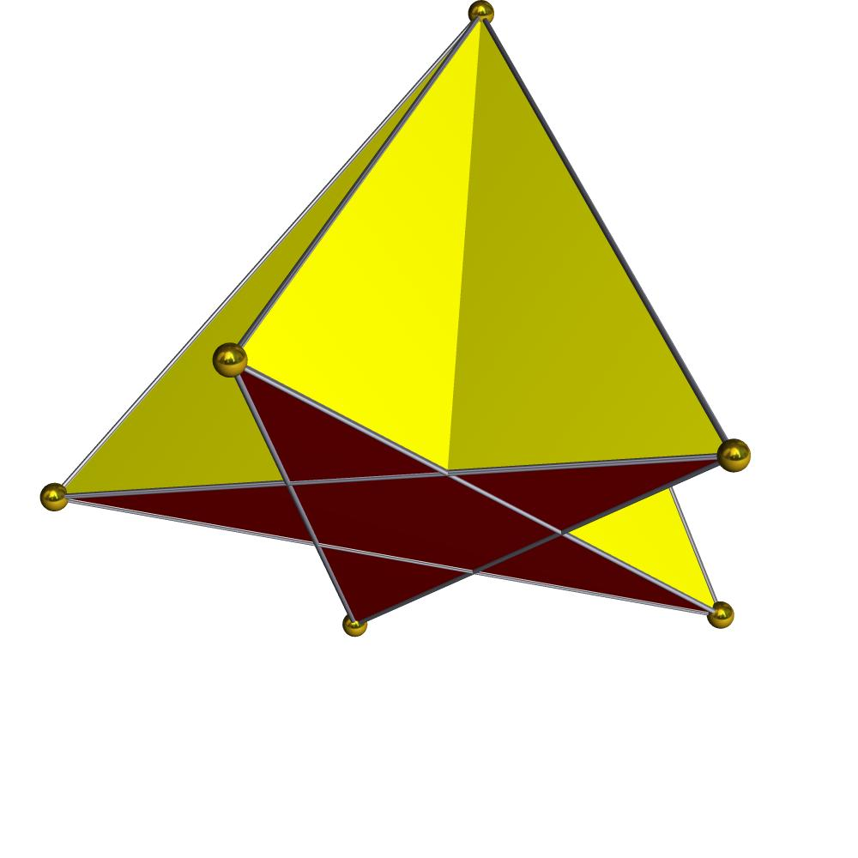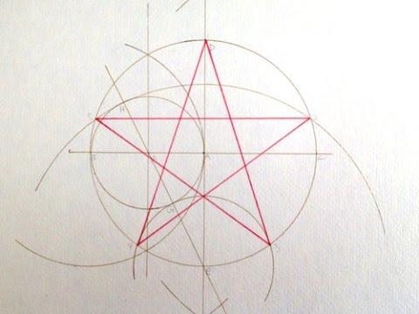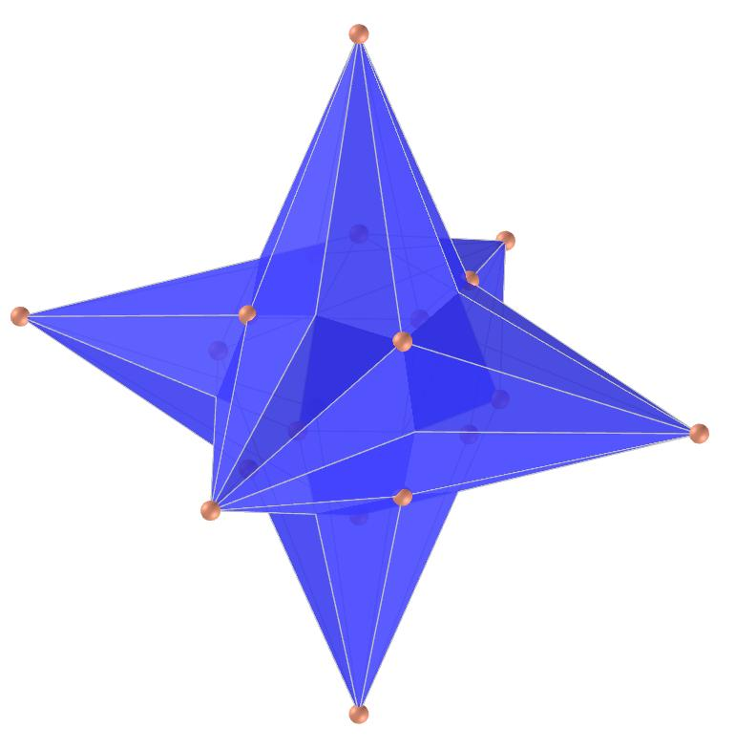

Key Points
# Source: AI Source: Provided by: [Data Path: Persons Table -> ID Column: 1, Name_En Column: Motasem Essam] -> From: [ChatGPT] on [7/25/2026]
- A star bipyramid uses a star-shaped central polygonal arrangement.
- It has two opposite apexes.
- Its external faces can be triangular.
- Its exact geometry depends on the star polygon and the way its vertices are connected.
- It should not automatically be classified as a regular polyhedron.
- A self-intersecting star construction may require special treatment when calculating volume and surface area.

Conclusion
# Source: AI Source: Provided by: [Data Path: Persons Table -> ID Column: 1, Name_En Column: Motasem Essam] -> From: [ChatGPT] on [7/25/2026]
A Star Bipyramid is a star-based extension of the conventional bipyramid structure. It combines two pyramidal portions around a star-shaped central arrangement, producing a distinctive three-dimensional form.
Classification note: The term Star Bipyramid is descriptive rather than a single universally standardized polyhedron name. For a precise taxonomy, distinguish between a bipyramid over a concave star-shaped polygon and a self-intersecting star-polygon bipyramid.

